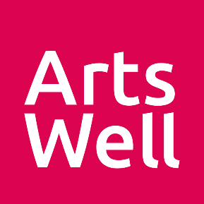
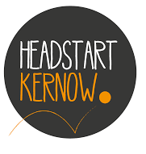
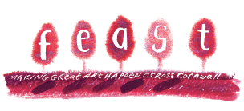

FREE CREATIVE PROGRAMMES FOR SCHOOLS AND YOUNG PEOPLE’S GROUPS
IN CORNWALL!

Headstart Kernow, FEAST and Arts Well are offering young people around Cornwall the opportunity to have free creative sessions with local artists. This could be a series of workshops, a one-off masterclass, an interactive performance or something else! Sessions will take place from March 2022 onwards, subject to artist availability. Young people will be invited to co-create the projects with artists if they would like to.

Young people must be:
- Aged 10 – 16
- Living in Cornwall
- Able to take part in a group (this programme is not for individual young people)

To register your interest, tell us a bit more about your organisation and young people. We would love it if you can complete this form with them.
Your name
Your contact details | Email |  | Tel
School / Youth Group / Organisation
Your role
Where are the young people based?
Where would the activity take place, ideally?
What age are the young people?
What is the group size?
Are there any artforms the young people are particularly interested in? Please list no more than 3
Are there any access requirements in the group?
Are there any personal goals the young people have around the creative activity that you’d like to share? For example, increasing their social skills, building resilience
Thanks for the info!

Please send your form to izzy@creativekernow.org.uk by
Friday 25 February. We’ll be in touch after this to let you know if we can provide you with an artist.

